HOME PAGE



REGISTER PAGE



DATA STORED IN MYSQL

1.USER

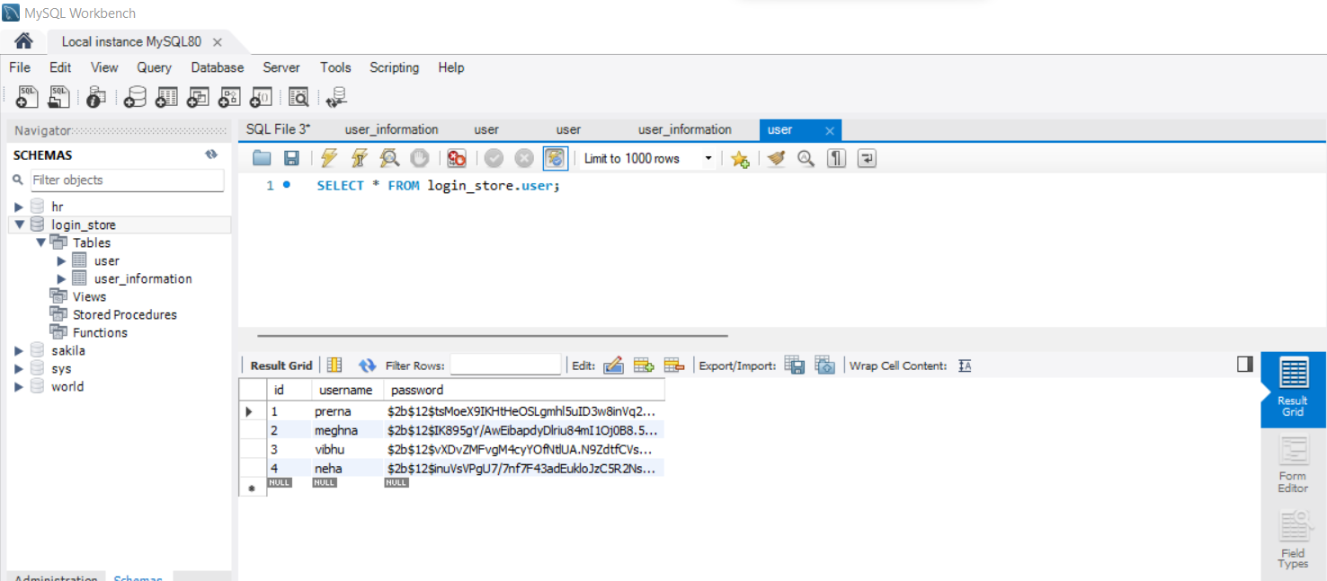

2.USER_INFORMATION

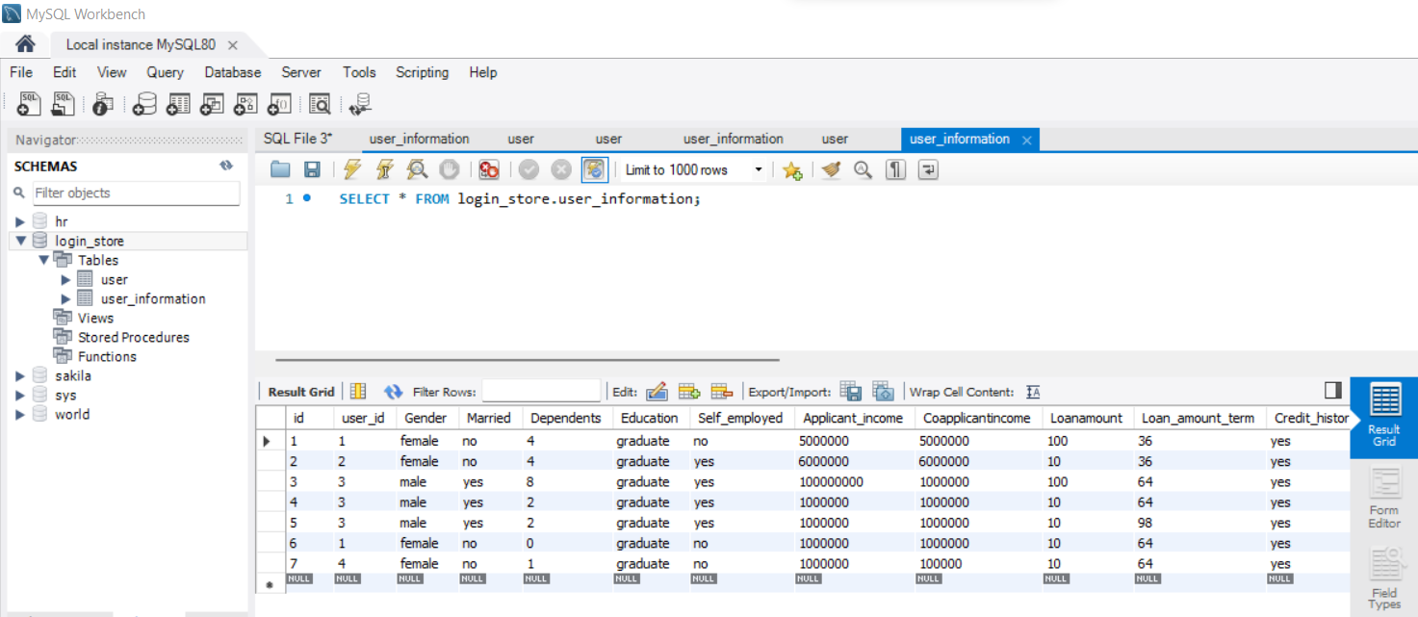

LOGIN PAGE

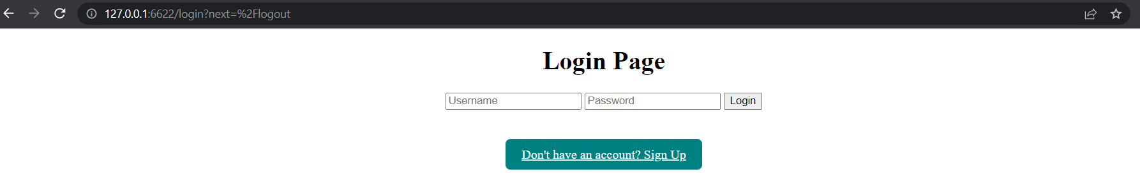

PREDICTION PAGE

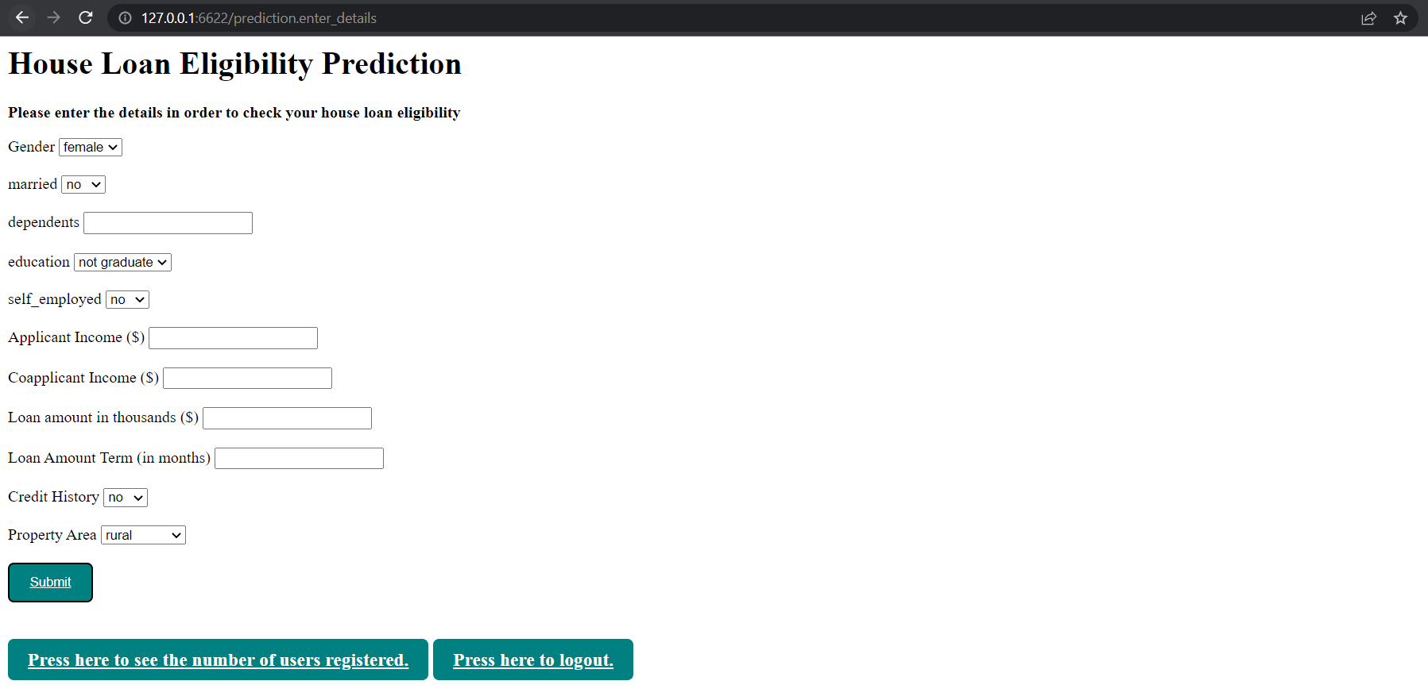

PREDICTED RESULT ON PREDICTION PAGE 